ቢቲዲ ትሬዲንግ ኃ.የተ. የግል. ማህበር

BTD Trading PLC
0928571296 / 0939008772 /0904351731

COMPANY PROFILE OF BTD Trading PLC

“OFFER FOR THE SUPPLY OF Cleaning SERVICE”
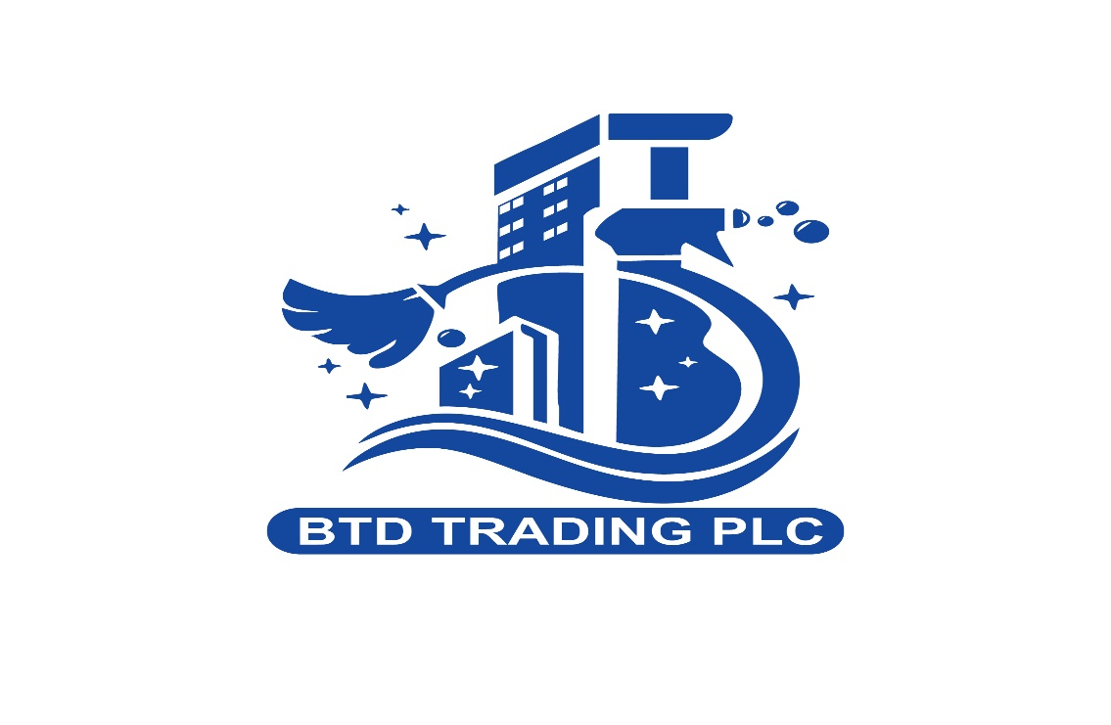

BTD Trading PLC
ADDIS ABABA-ETHIOPIA/ Megenagna /Amecha/
TEL:+251 928-57-12-96 +251 939-00-87-72 +251 904-35-17-31

Introduction of our company

1. COMPANY PROFILE
BTD Trading PLC is a professional company providing high-quality, reliable, and long-term and one-time cleaning and facility support services to both Government and Non-Government Organizations. We serve clinics, hospitals, offices, markets, malls, schools, and commercial buildings with a strong focus on hygiene, safety, and customer satisfaction.

2. OUR MISSION
To provide reliable, affordable, and high-quality cleaning services that create hygienic, safe, and productive environments for our clients through professionalism, integrity, and continuous improvement.

3. OUR VISION
To become one of the leading and most trusted cleaning and facility service providers in Ethiopia by setting high standards in cleanliness, safety, customer satisfaction, and service excellence.

4. OUR CORE VALUES
- Professionalism
- Honesty & Integrity
- Customer Satisfaction
- Teamwork & Respect
- Health, Safety & Hygiene
- Reliability & Accountability
- Continuous Improvement

5. OUR DAILY CLEANING SERVICES
General Cleaning Services:
- Floor sweeping, mopping & polishing
- Furniture & surface cleaning
- Door, wall & window cleaning
- Elevator & staircase cleaning
Sanitation & Hygiene Services:
- Toilet & bathroom deep cleaning
- Disinfection of high-touch areas
- Waste collection & safe disposal
Specialized Services:
- Clinic & hospital sanitation
- Market & mall cleaning
- Emergency & event cleaning
- Weekly & monthly deep cleaning

6. SERVICE SCHEDULE & CONTRACT TERMS
- one-time cleaning service for Final cleaning of completed buildings
- Flexible shift schedules (morning, evening,)
- Short-term & long-term contracts (1–3 years or more)
- On-site supervision
- Emergency response available

7. WHY CHOOSE BTD TRADING PLC
- Trained & disciplined staff
- Professional supervision
- Standard cleaning equipment & materials
- Affordable pricing
- Fast response & strong communication
- Long-term partnership approach

8. HEALTH & SAFETY COMMITMENT
We follow strict workplace safety rules, proper chemical handling procedures, use of protective equipment (PPE), and infection prevention standards.

9. PRICING & PAYMENT
Pricing is customized based on facility size, service type, working hours, and number of cleaners required. A free site visit and quotation will be provided.

10. OUR COMMITMENT
BTD Trading PLC is committed to delivering consistent cleanliness, safe environments, disciplined staff, and transparent service management.

Thank you for choosing us.

